

**MEMORANDUM OF UNDERSTANDING**

This is a document validating an agreement between **MR. OGABOR JOHN AND MR. DANIEL BODAFI** for the collaborative of 20% interest over a sum of **TWO HUNDRED THOUSAND NAIRA ONLY (N200000) paid on the 11th of May, 2020.**

There is a binding agreement to pay the initial capital invested, alongside the interest, **TWO HUNDRED AND FORTY THOUSAND NAIRA ONLY (N240000) on the 10th of June, 2020** by **MR. OGABOR JOHN TO MR. DANIEL BODAFI.**

Attached with this document is an evidence of payment by **MR. DANIEL BODAFI.**

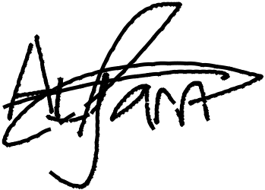

_________________________

_~~__~~_____~~___~~_~~_~~___________



**MR. DANIEL BODAFI**

**MR. OGABOR JOHN**

***(CEO, JOHN INVESTMENTS)***